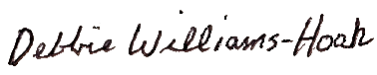

Presented To

~ Name~

Spring 2021

1st Team All-State

Division 4

MIGCA President

Coach